

# **Solution Test Bench – HPAC User Guide**

Contents

**Solution Test Bench – HPAC User Guide** 0

Add Print Queues to STB 2

Add Devices to STB 4

Steps to Add Plugin Reference 6

Import Scenario and Configuration 7

Device Bulk Edit Tool 10

Running the scenario 12

Report Generation 15

Troubleshooting Reports 20

STB Log Files 21

Troubleshooting Scenario Execution 21

Before applying the HPAC package to the Solution Test Bench (STB) installation, it is assumed that:

* STBServer-Base installation has successfully been run on the host machine.
* At least one Print Device exists in the Print Device Inventory, and at least one Print Server exists in the Print Server Inventory. These can be added via the STB Admin Control Panel app:  > Solution Test Bench > Admin Control Panel (OR) C:\VirtualResource\Distribution\ControlPanel\hpstbcp.exe
* The HPAC package is being applied to the server machine (not the client).

# Add Print Queues to STB

1. Launch the Admin Control Panel from  > Solution Test Bench > Admin Control Panel (OR) [C:\VirtualResource\Distribution\ControlPanel\hpstbcp.exe](../../../VirtualResource/Distribution/ControlPanel/hpstbcp.exe).
2. Under **Print Automation**, click on Print Server Inventory. You should see the following form:

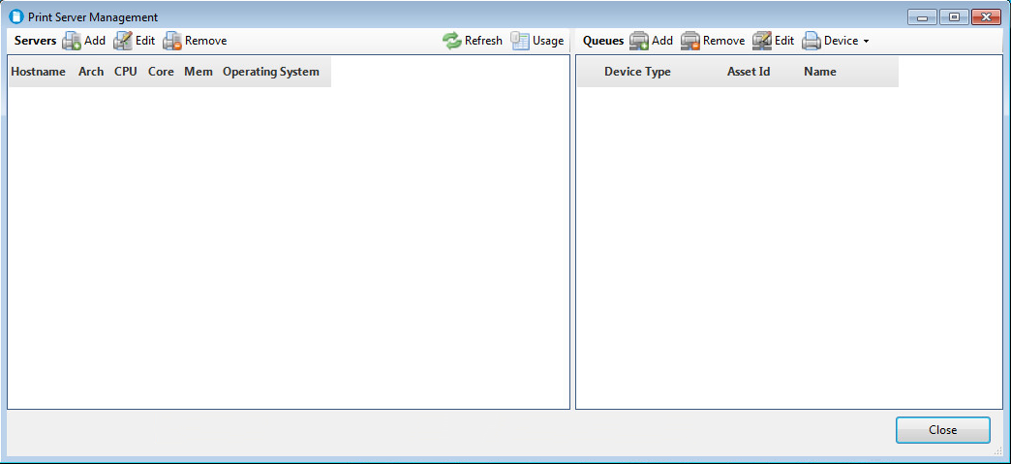

1. In the upper left quadrant next to **Servers**, click on the **Add** button.
2. Enter the host name of your HPAC server. Note: It is assumed that your HPAC server contains a publicly shared print queue that is monitored by the HPAC software. Click **OK**.

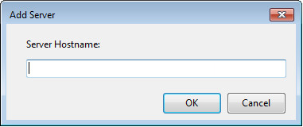

1. The STB software retrieves basic statistical information about the server and presents it in the following form. Make sure the Server Attributes are selected as shown. Click **OK**.

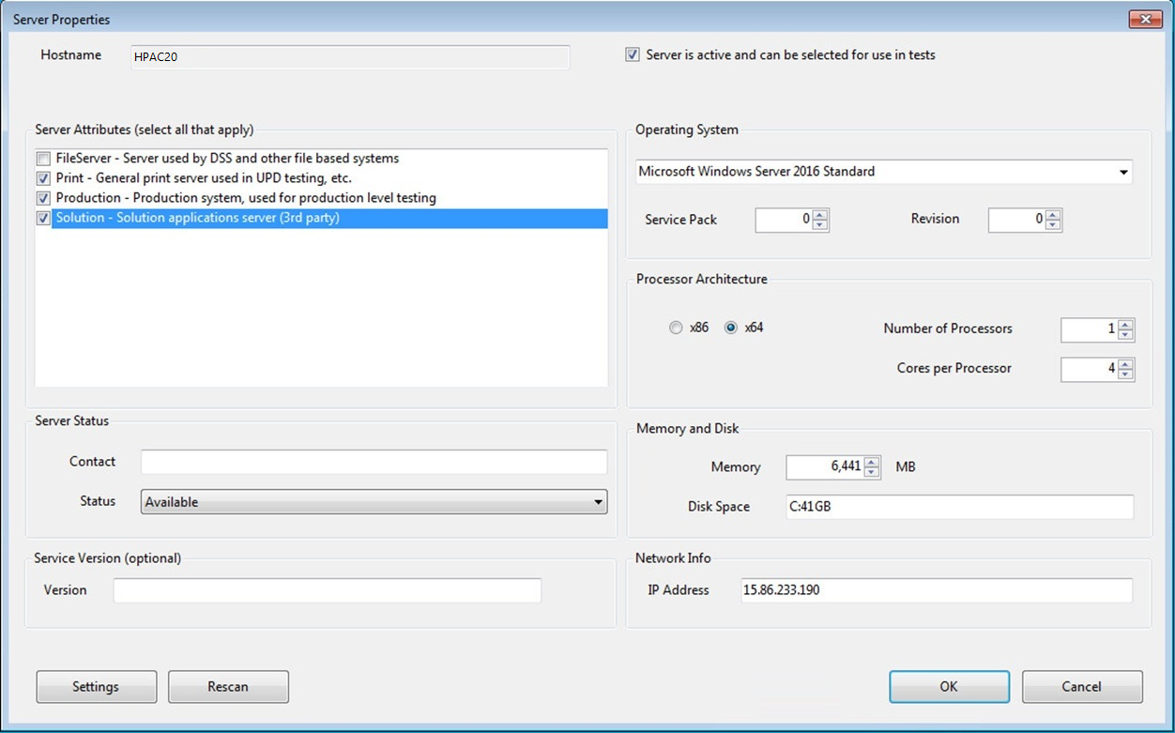

1. After the software scans the server for print queues, you should see the following message. Click **OK**

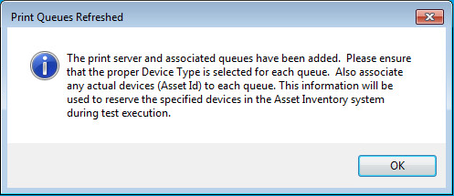

1. The HPAC server and it’s public print queues are now added to STB. Close the form.

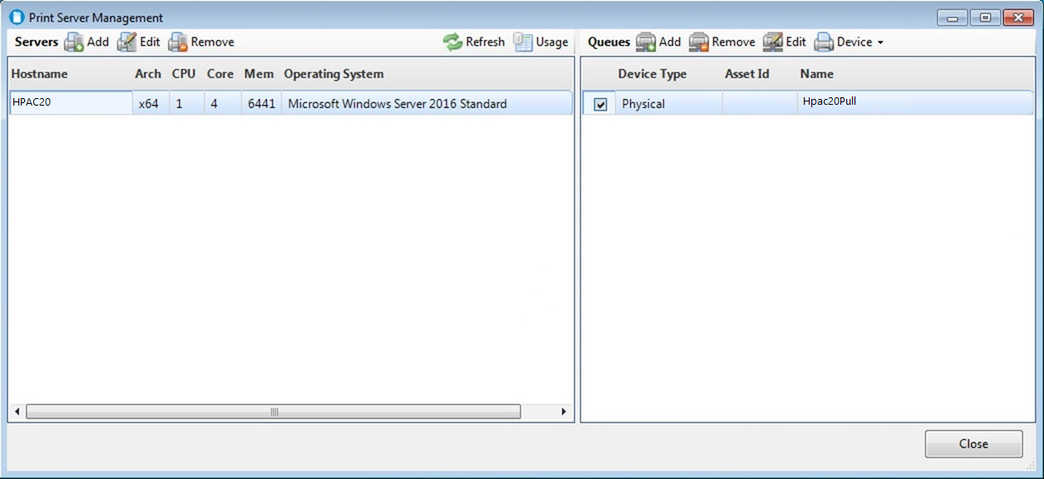

# Add Devices to STB

1. Launch the Admin Control Panel from  > Solution Test Bench > Admin Control Panel (OR) [C:\VirtualResource\Distribution\ControlPanel\hpstbcp.exe](../../../VirtualResource/Distribution/ControlPanel/hpstbcp.exe).
2. Under **Print Automation**, click on Print Device Inventory. You should see the following form:

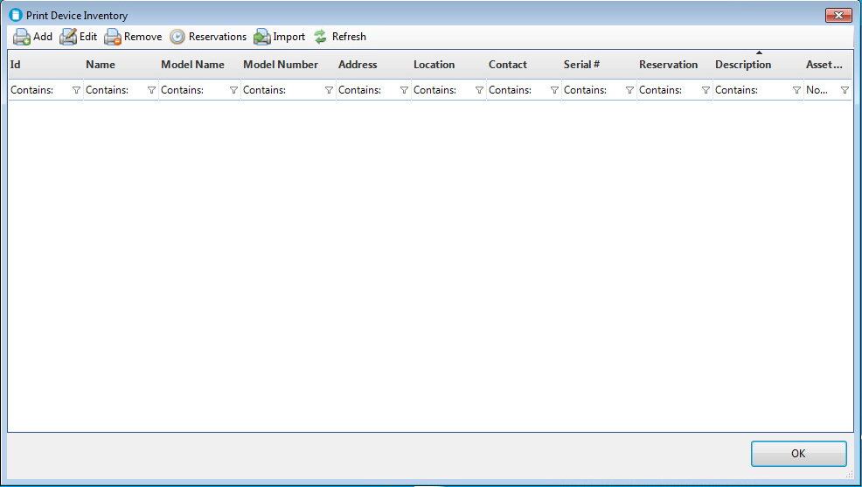

1. In the tool bar in the upper left, click on the **Add** button.
2. Enter the IP address of your test device and the device’s administrator password. Click **OK**.

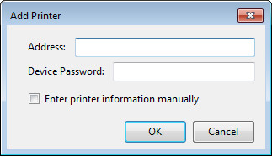

1. The software will then scan the device and present the following form. Make sure to enter a unique ID for the printer, and check the 3 capabilities at the bottom of the form as shown. Click **OK**.

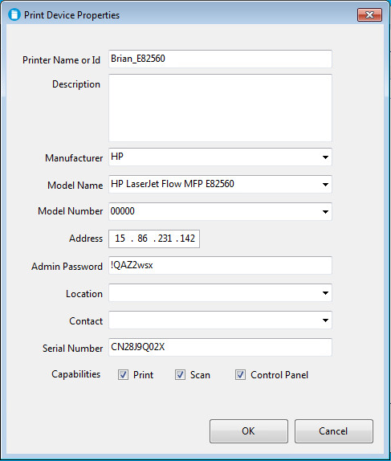

1. You will be prompted for an Inventory Pool Name. Select “DEFAULT” and click **OK**.
2. The device is now added to the Print Device Inventory. Click **OK**.

Copy Package Data to STB Install Locations

1. Using Windows Explorer, browse to the location where the HPAC package was extracted. Within the package folders, you should see the following folders:

Package

Reports Template

STB Install

1. Locate and double-click the folder named “Package”. Within the Package folder, select all of the files named “Plugin.XXXX.dll”, and drag/drop them into the STB installation directory: C:\VirtualResource\Distribution\Plugin
2. Next, locate and double-click the folder named “Reports Template”. Within that folder, select all files and drag/drop them into the STB Reports installation directory:

C:\STBShare\Reports

# Steps to Add Plugin Reference

1. Launch the Solution Test Bench User Console from  > Solution Test Bench > STB User Console (OR) C:\VirtualResource\Distribution\ControlPanel\hpstbcp.exe
2. Click on **Activity Plugin References** under the Administration menu item.
3. Click on New Button > Select the **Plugin.HpacPullPrinting.dll** from the Dropdown.

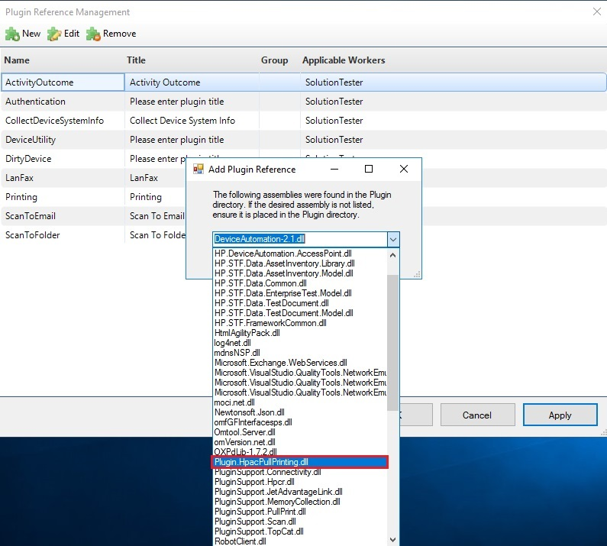

1. Click on OK
2. Input the Plugin Title. This is the title displayed in STF when creating a new instance of the HPACPullPrinting plugin. Select the “Solution Tester” Checkbox Highlighted below, then click on OK Button.

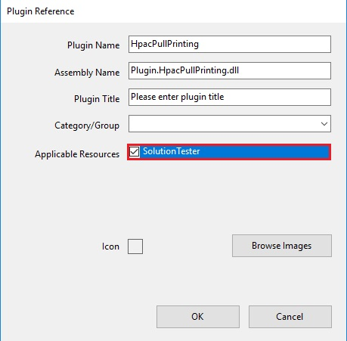

1. Follow the Same Step 4 to 6 for Plugin.Authentication.dll and Plugin.DirtyDevice.dll. Click on Apply to add all the above plugins to STB. Note that Plugin.DeviceUtility.dll was included your package, but is only a supporting library, not an actual plugin. You do not need to add Plugin.DeviceUtility.dll using this utility.

# Import Scenario and Configuration

1. Launch Solution Test Bench User Console from  > Solution Test Bench >STB User Console (OR)  C:\VirtualResource\Distribution\STBUserConsole\SolutionTestBench.exe
2. Click on the Import Scenario under File menu

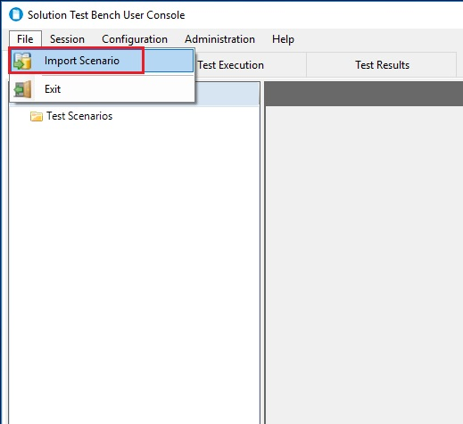

1. Browser the Scenario file (.stbs) under **Import file** in the Scenario Import Wizard. The Scenario files are located in the extracted HPAC package in the same location as plugins <UnzippedPackageFolder>\Package click on **Next** button.

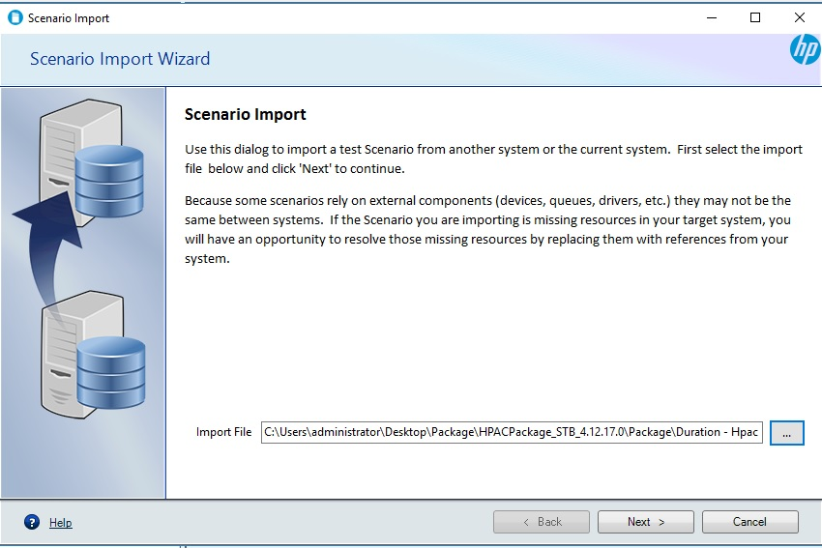

1. The Scenario name and description can be changed or left as it is. click on **Next** button.

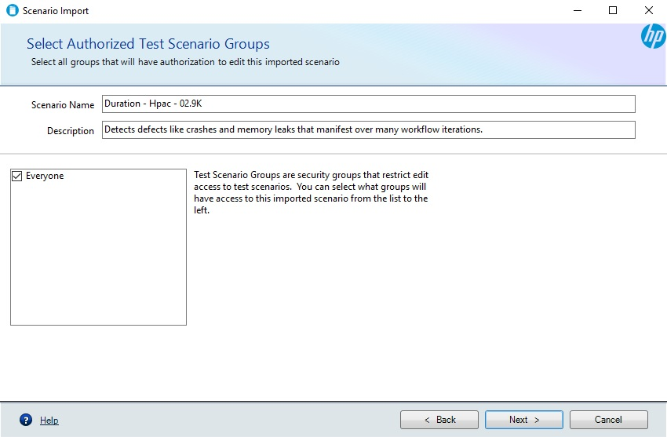

1. Select the Destination folder and click on finish button

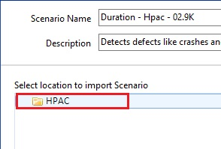

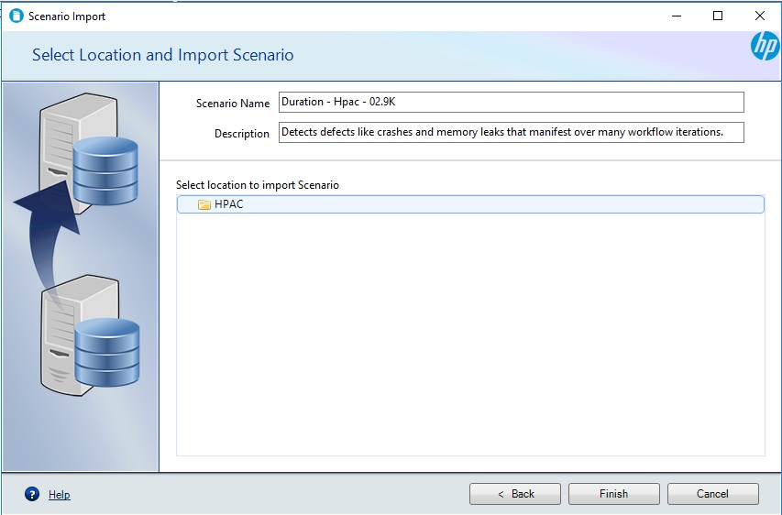

1. After import, a message is displayed:

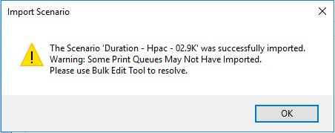

This warning message displays because the import operation was not able to match the resources of the imported test (like Print Queue, Print Device, Print Documents, etc.) with the resources in your STB environment. Continue to the next section to resolve the issue.

# Device Bulk Edit Tool

1. After importing a scenario, the print queues and devices from the original scenario most likely will not match the ones in your system. The Bulk Edit Tool can be used to replace all the devices in a scenario with other devices. Select the scenario under root structure and click on **Device Bulk Edit.** The Device Bulk Edit is an easy way to select a device for all plugins.

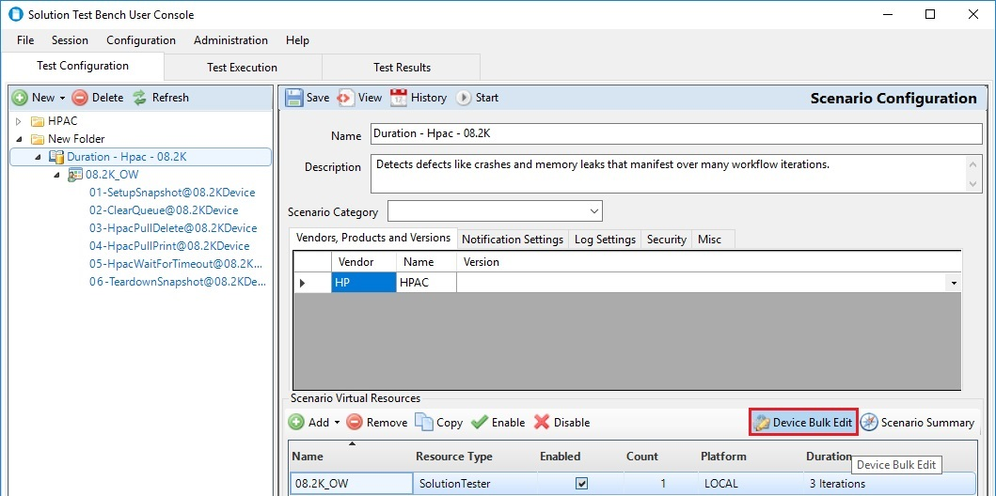

1. Click on change button and select the target device

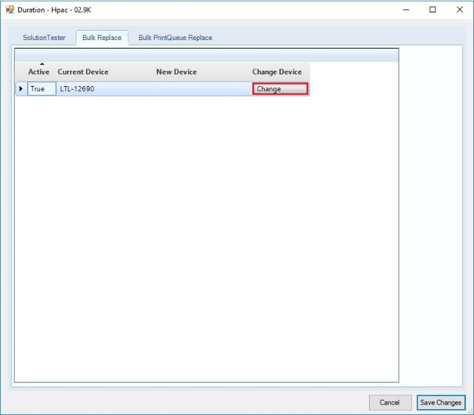

1. Change the device as desired for each plugin shown below and click on **Save Changes** button

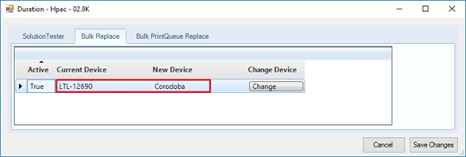

1. Click on Save button as shown below on the main STB window

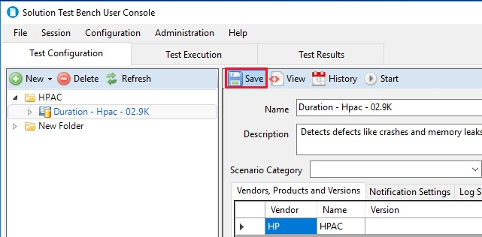

# Running the scenario

1. In the configuration Tree at the left, drill down into the scenario. The next level in the scenario is the Solution Tester. Click on the Solution Tester to view the settings. Select the User Account Tab as shown below. Make sure a User Pool is selected and also the “**Run the Solution Tester process using the same account selected above**” radio button.

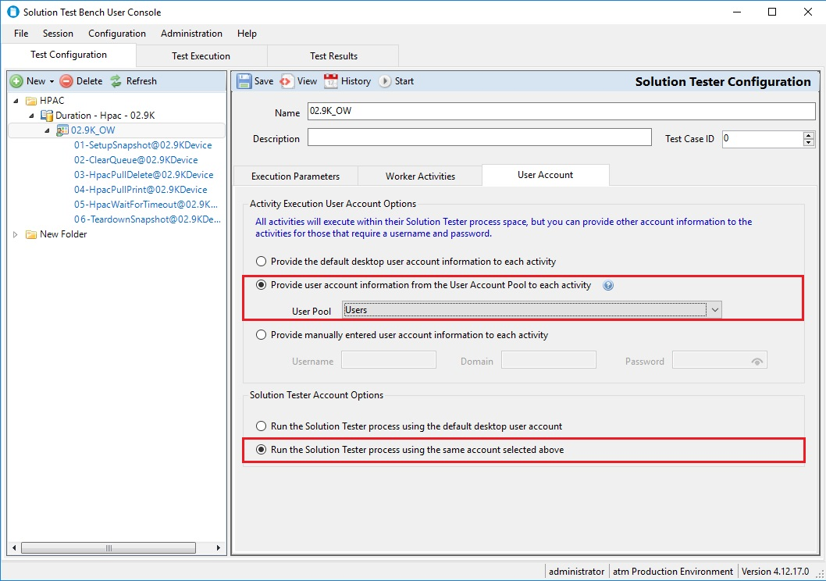

This setting forces STB to run the test processes as actual users that should exist on your domain. If the users defined in your user pool do not exist on your domain, the test will not start. See HP Solution Test Bench – Installation and Administration Guide (page 37) for more information on adding Virtual Worker Pools to STB. For troubleshooting common user account issues when starting a scenario, see the section at the end of this document.

1. Click on the Start button as shown below

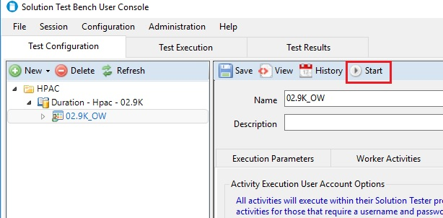

1. Select the Session Type from the dropdown and provide the estimated Runtime. If the scenario is a duration or a scheduled test, the software will calculate the Estimated Runtime. If the scenario is an iteration test, the tester will have to give their best guess for estimated run time. Please note that device reservation times are associated with the Estimated Runtime which means that if the test extends beyond the Estimated Runtime, the device reservations could expire in the middle of the test. A generous estimate for the Estimated Runtime is therefore encouraged. Click on **Next** button to proceed.

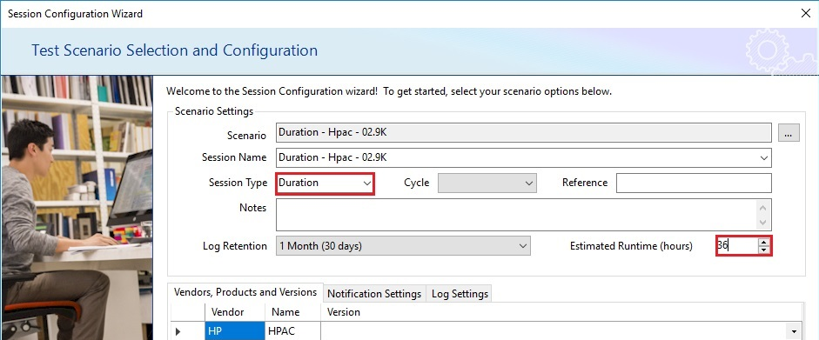

1. The Start-up Wizard checks the Asset Inventory for device availability. The device should be available for the run in the Asset Reservation screen as shown below (green checkbox). A red icon with a white “X” in the middle indicates a problem with the device reservation. Click on **Next** button.

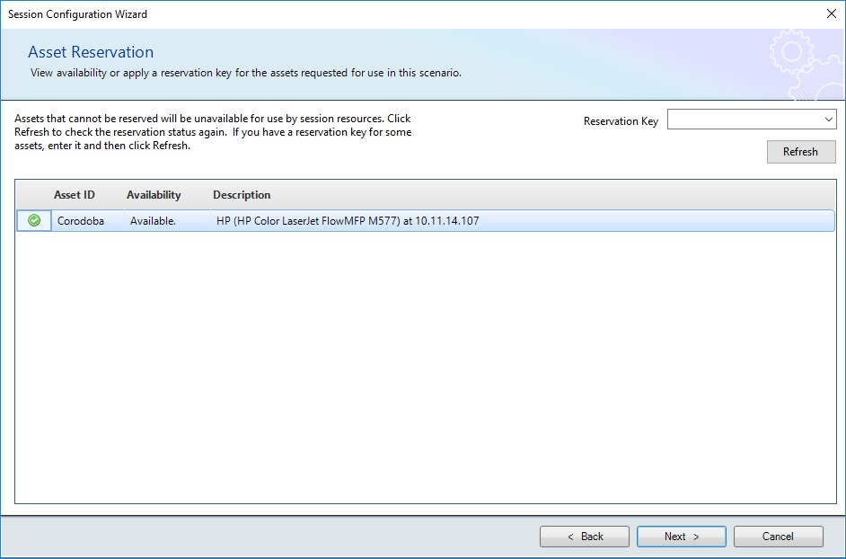

1. Device Paperless Mode is turned on by default. Unchecking this option will cause the devices to print all print jobs during the test. Click on **Next** button.

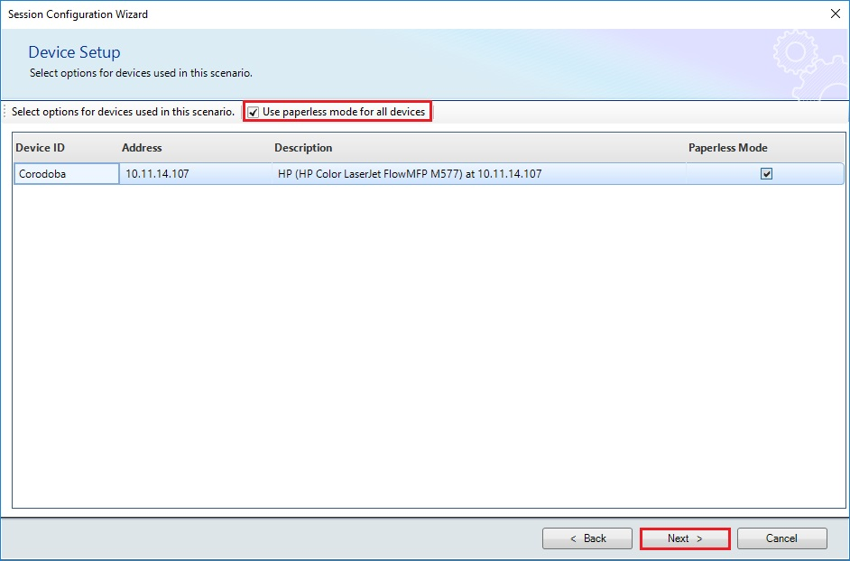

1. Wait for the Asset validation to complete. Once it is validated, **Start Session** button should be enabled. Click on Start Session to start the execution.

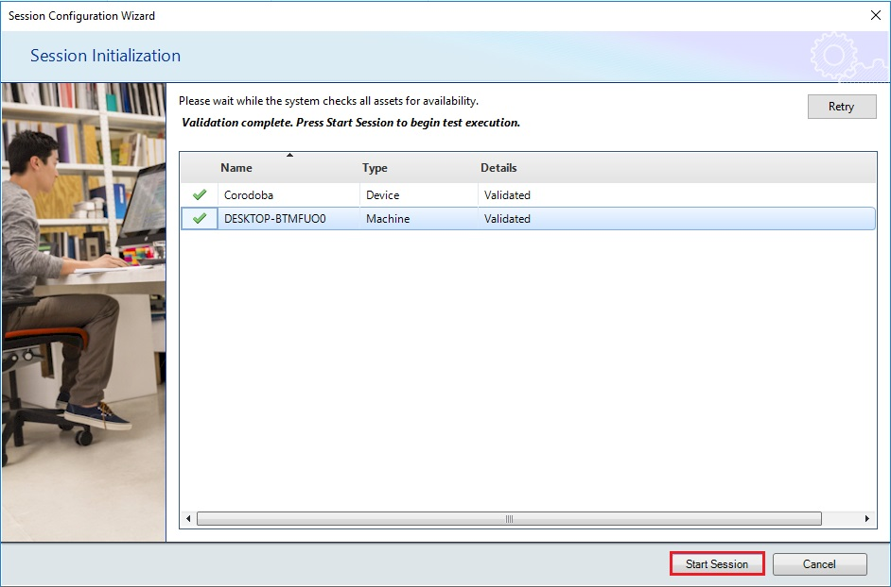

# Report Generation

STB uses Excel to pull data and display it as a report. The reports are shipped at templates, meaning they contain connection information and formulas for displaying data, but there is no data in the report templates. Once the user selects and saves a report template, it is necessary to “refresh” the data before the report will display the data. By default, the report templates are stored on the STB server at C:\STBShare\Reports

1. Open STB User Console.
2. Under **Session** menu item, select **Session Reports**.

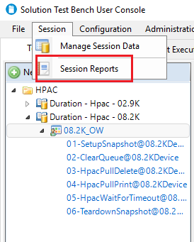

1. Select the respective Session Id to generate the report, then click on **Browse**.

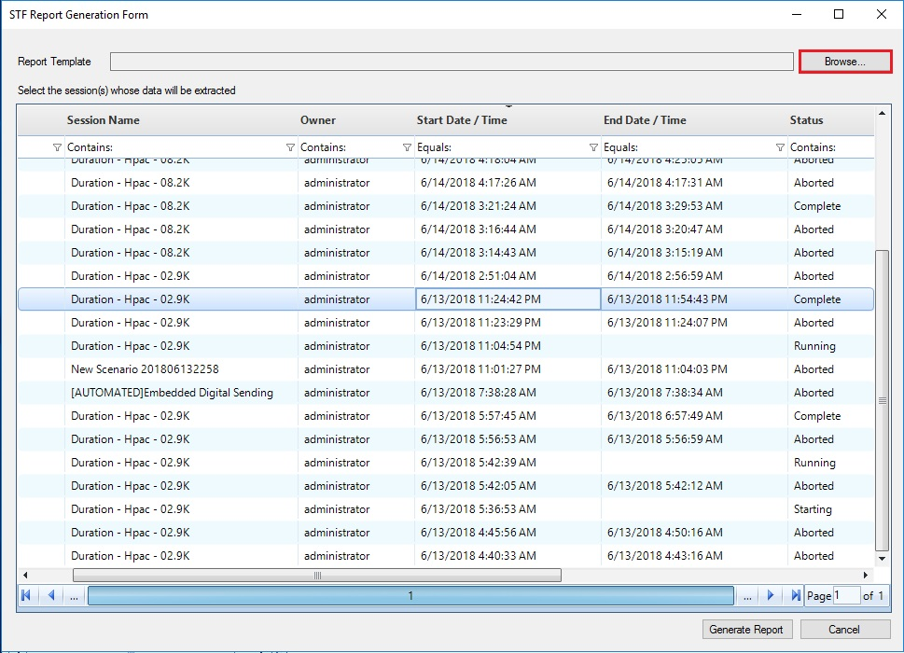

1. Select the desired report from the specified path. The example below selects the “DeviceMemoryReport.xslx”.

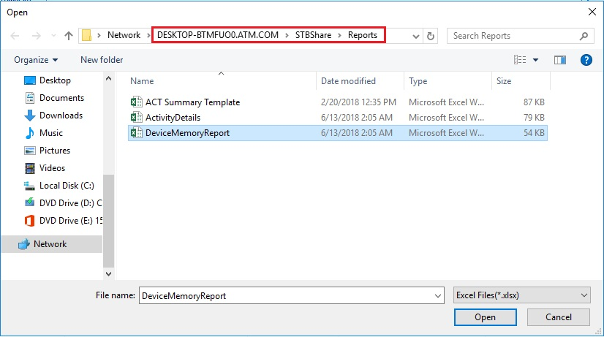

1. Click on Open.

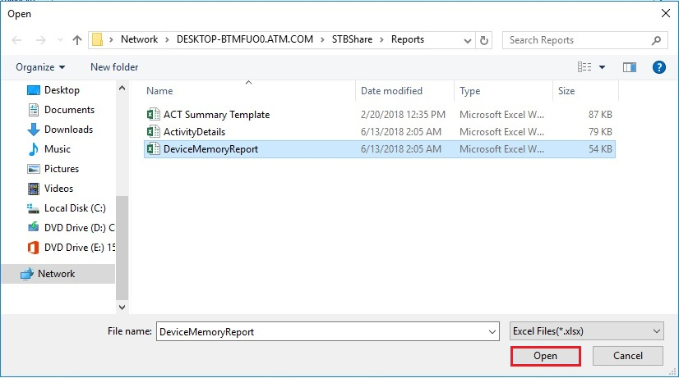

1. Click on Generate Report.

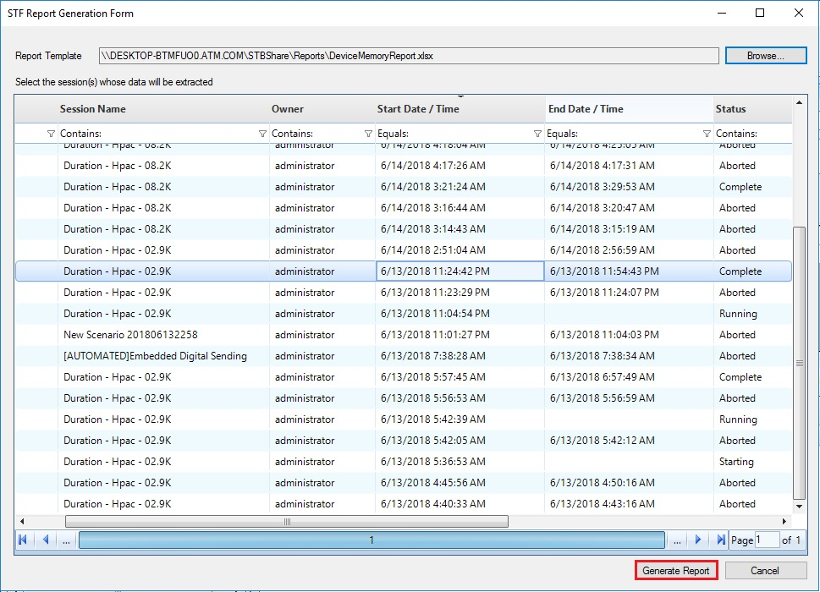

1. Save the new, renamed file.

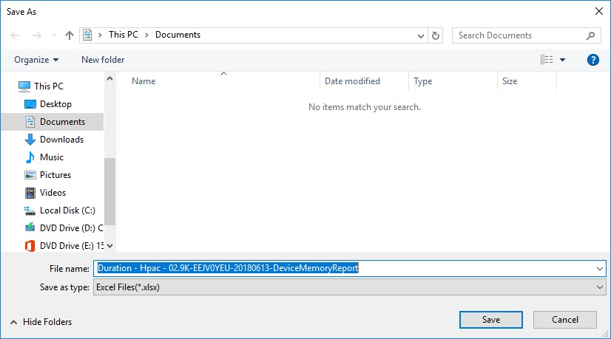

1. Open the saved report, Click on “Enable Content” if prompted.

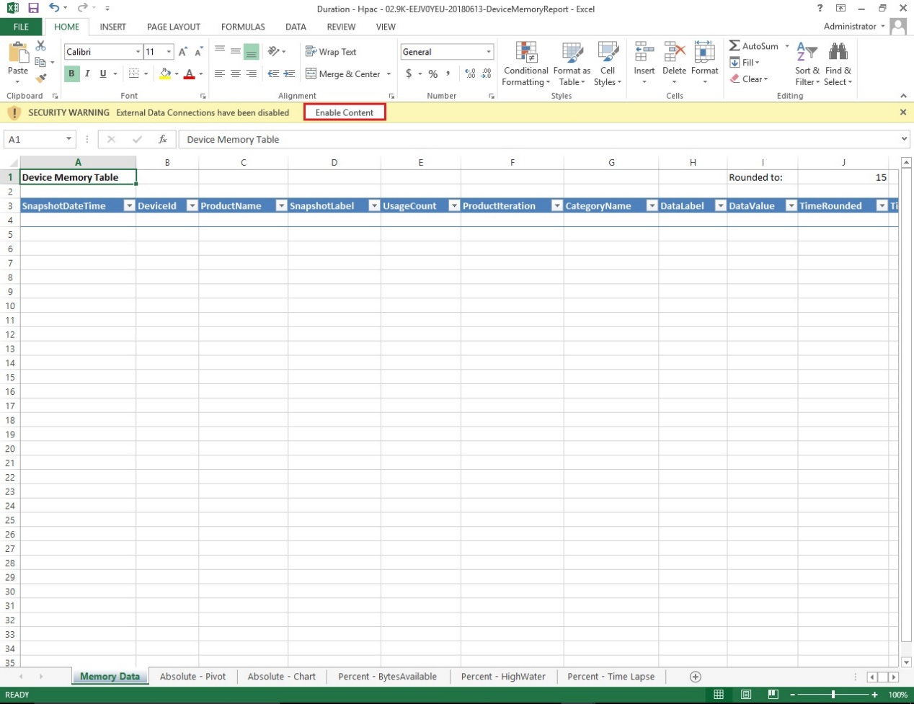

1. Navigate to DATA menu item in the top menu of Excel.

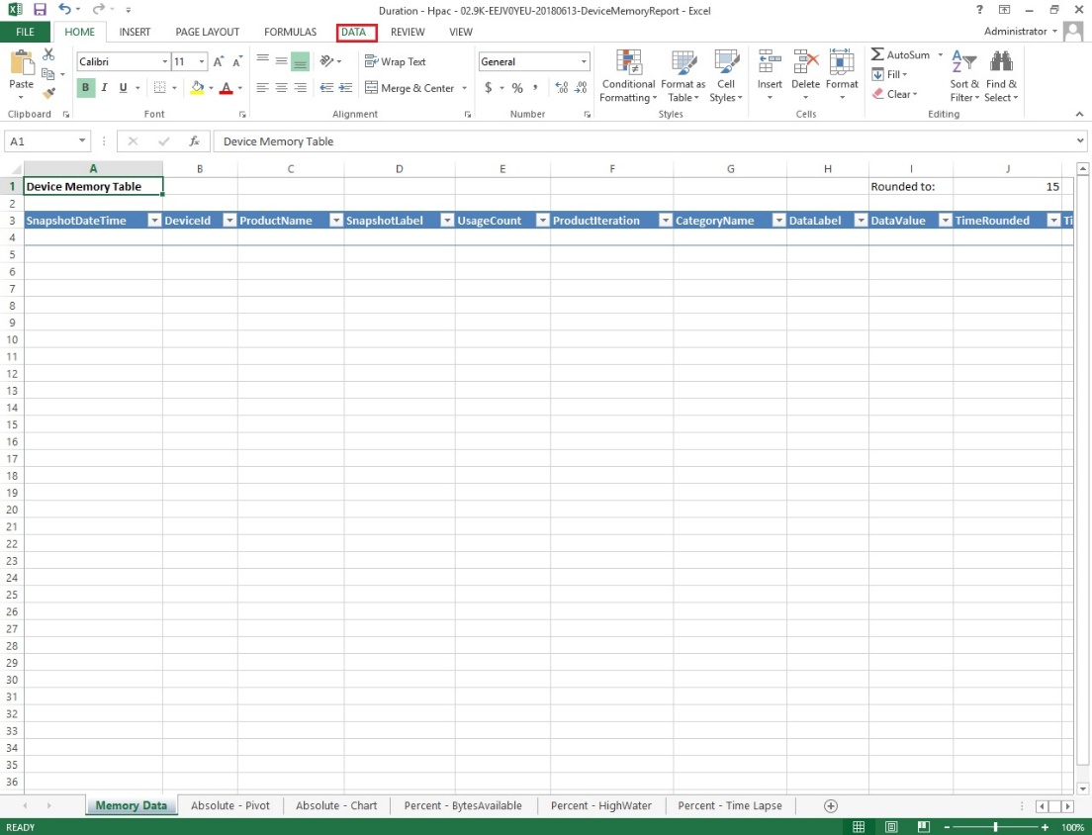

1. Click on “Refresh All” to update the spreadsheet. Sometimes the data does not refresh. It is recommended to click “Refresh All” multiple times. As you browse the sheets, you may need to click on “Refresh All to update the data in the sheet.

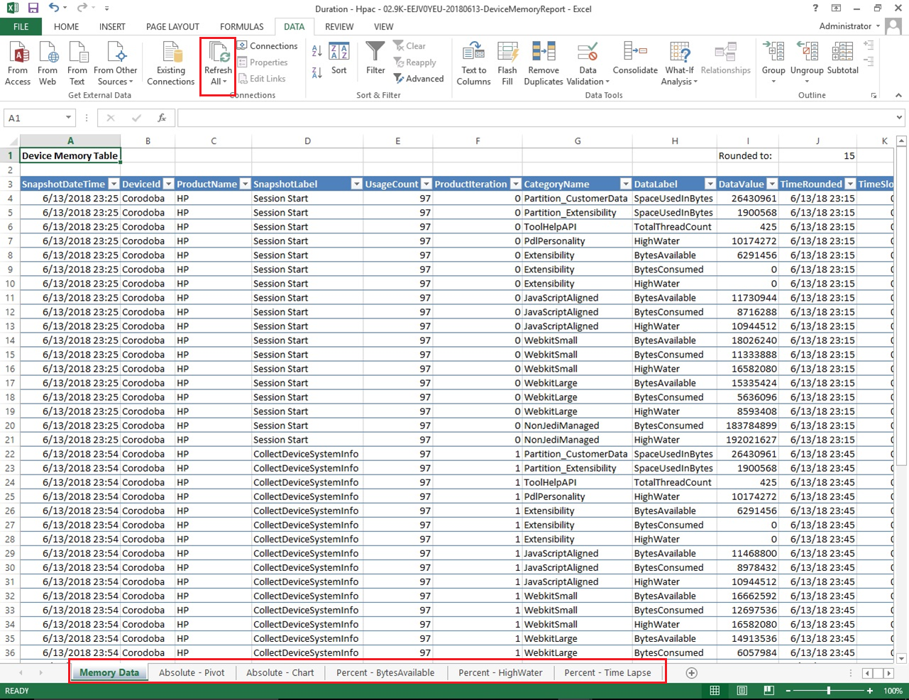

1. Save the Report.

# Troubleshooting Reports

The following steps need to be followed **ONLY** if there is an issue with the report generation,

Or if the spreadsheet displays an empty report on a refresh

1. Open the saved spreadsheet > Navigate to Data tab > Connections
2. Double click on > Activity summary > navigate to definition tab
3. Under connection properties replace the Workstation ID with the **Hostname** of the STB Server
4. Under Command text, Replace “{Session ID}” with **Session ID**
5. Click on OK
6. Repeat Step 2-5 for **Servicemembers**, **Device Summary**, **Document Summary** and **Session Summary**
7. Close and click on **Refresh all** under **DATA Tab**

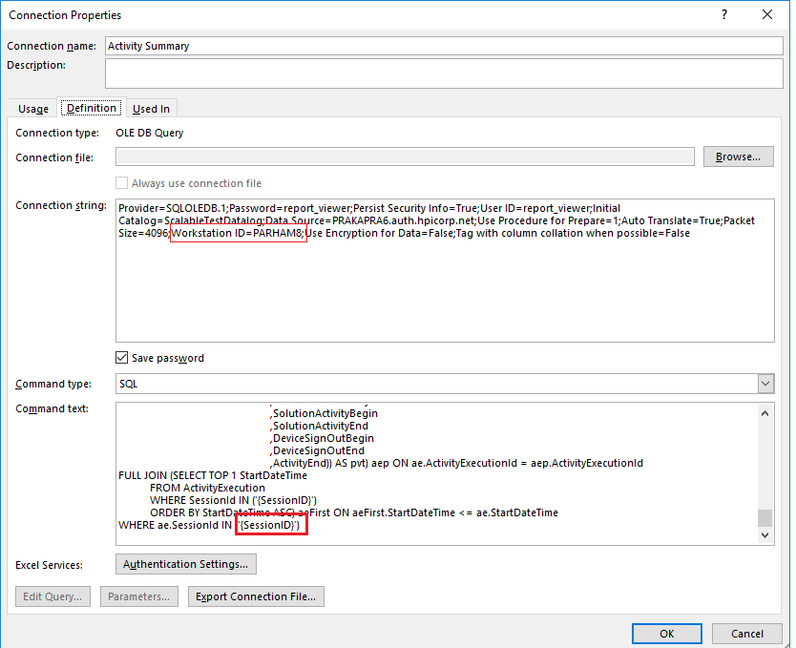

# STB Log Files

All STB executing processes create log files. The log files can be very helpful in troubleshooting and are essential to the support process. When contacting HP about STB related issues, you can expect to be asked for the STB log files. The log files can be found at the following locations:

STB Console

C:\VirtualResource\Distribution\STBUserConsole\Logs

STB User Processes

C:\VirtualResource\Distribution\SolutionTesterConsole

STB Data Service

C:\VirtualResource\Distribution\DataService\Logs

# Troubleshooting Scenario Execution

This document recommends the use of User Pools when executing a scenario (see section “Running the Scenario”, step #1). When a scenario first runs in a new environment, it is common to experience errors related to user permissions regarding the user pools. There are several different permissions related errors that could be seen.

Impersonation

STB starts each user process using impersonation. Impersonation is the ability of a thread to execute other threads (or processes) using different security information than the process that owns the thread. The STB User Console executes as the currently logged-in user. When STB starts a new session, it creates new user processes (using the user configuration information from the user pools) by impersonating the users as themselves. In order for the impersonation operation to work, the currently logged-in user MUST have local administrator permissions on the machine where STB is executing. This is the first thing to check if you are experiencing errors during session startup.

Local Administrators

During testing, a user process may need to copy test documents, rename test documents, and remove the copies of the test documents during test execution. To ensure the user process has the permissions to execute all of that on the local machine, STB adds each user in the user pool to the local Administrators group. Part of the process of adding the users in the user pool to the Administrators group is to retrieve the list of all users that currently are members of the Administrators group. Sometimes there are domain users that are members of the local Administrators group that the currently executing user process does not have permissions to view. Remember that the currently logged in user needs to be a local Administrator. Local Administrator permissions does NOT grant permissions to view information about other domain users that are also part of the local Administrators group. So, if the machine upon which STB is executing contains domain users in it’s Administrators group, this may be the cause of the startup errors. In this case, the specific error that is generated is:

COMException (0x80070035): The network path was not found.

You may not actually see the text of this error in an error message, but if you check the log file for the STB User Console, you can find this error logged there. If you find this error message in the STB User Console log file, check the Administrators group on the machine where STB is executing and remove any domain users you suspect the currently logged-in user may not have permissions to view. Even if the currently logged-in user SHOULD have permissions to view the domain users, it may resolve the startup issues by removing those users from the local Administrators group.

In summary, if you are experiencing session startup issues, try the following:

1. Check the STB User Console log file for errors related to startup. Errors related to starting up a user process, or permissions errors, or “The network path was not found” are good candidates for the issues described in this section.
2. Check the local Administrators group for the currently logged-in user and add it, if it is not already there.
3. Check the log file for “The network path was not found.” and remove other domain users from the local Administrators group if this error is present in the log file.